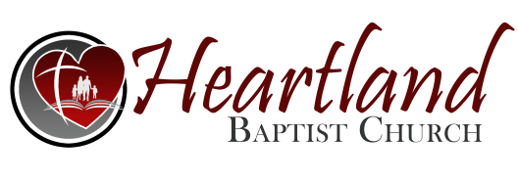
Wednesday, 6-28-2023
Pastor Gruber

Biblical ELEMENTS of Music PART 3
Psalm 40:1-3
Music Should Have a Biblical THEME
Music Should Have a Biblical TEST
- It Should Pass the TEST of _______________________
- It Should Pass the TEST of _____________________
Romans 12:1-2; James 4:4; I John 2:15-16
- RESIST _______________ ...by the mercies of God... · Justification from the __________ and penalty of sin. · ________________ by the Father through Jesus. · Placed under ____________, not law. · Giving the _________ __________ to live within. · Promise of help in all _________________. · __________________ of a standing in God’s election. · Confidence of coming _____________. · Confidence of no __________________ from the love of God. · Confidence in God’s continued _________________.
- RESIST _____________________ ...present your bodies... Mercies of God have a VERY _________________ power over our wills. The reference is that God wants ________ of us not just our works. Our bodies are the earthly tabernacle for who we truly are. It is a terrible ______________ but a wonderful ______________. When God has who we are, our body comes willingly in that _________________.
- RESIST _____________________ (apostasy, idolatry) ...a living sacrifice...holy... pure; without blemish
- RESIST _____________________ (detestable, foul) ...a living sacrifice...acceptable... well pleasing; fully agreeable
NOTES REGARDING LIVING SACRIFICE:
· The sacrifice is living because it is brought ______________ to the altar.
· The sacrifice is living because it ______________ alive at the altar; it is _______________.
- RESIST ______________________ …be not conformed… STOP
- RESIST _______________________ …friendship with the world…
- RESIST ________________________ …love not the world… STOP

